+-

***Print for Custom designed home***

* **Quick Print Details**
* Home is 24’x24’ Square with full basement.
* Cement block basement 12 block high
* 16’x24’ upstairs loft
* 16’ Shed Roof Dormer
* Metal Roofing
* Footings and cement layout shown
* All structure and beam layout shown
* MATERIALS COST ESTIMATE – last page

***Window Sizes (R.O.)***

1. Main Floor
   1. Two 60” x 48”
   2. One 48” x 48”
   3. Three 36” x 24”
2. Basement
   1. Two 36” x 24”
   2. Three 32.25” x 14.25”
3. Upstairs
   1. Two 48” x 48”
   2. Two 48” x 60”
4. **Total Windows**: 15 Windows

***Page Index***

1. House Exterior Southeast Corner
2. House Exterior Northeast Corner
3. House Exterior Southwest Corner
4. House Exterior Northwest Corner
5. House Exterior South Side Rafter Layout
6. House Exterior North Side Rafter Layout
7. House Exterior Top View Rafter Layout
8. House Interior Top View Joist Layout
9. House Interior South Side Joist Layout (Main Floor)
10. Upstairs Loft floor Joist Layout
11. Upstairs Loft Beam and Support Poles Layout
12. Basement Floor Plan
13. Main Floor Plan
14. Main Floor Plan Dimensions
15. Upstairs Floor Plan
16. Footing and Basement layout.
17. Sideview Rafter and Wall Joint Detail
18. North Side Exterior Wall Framing
19. East Side Exterior Wall Framing
20. South Side Exterior Wall Framing
21. West Side Exterior Wall Framing
22. Roof and Wall Exterior Insulation Details
23. Roof Peak Venting
24. East Side Deck Framing and Layout
25. West Side Deck Framing, Layout, and Footings
26. Site Plan (3D view of House, Drain Field, Septic, Well)
27. Site Plan Elevation Change
28. Satellite View of Property and Site Location
29. Materials Estimate

Design For:

Compass in Top Right Corner does not apply to 3D models with direction faces labeled

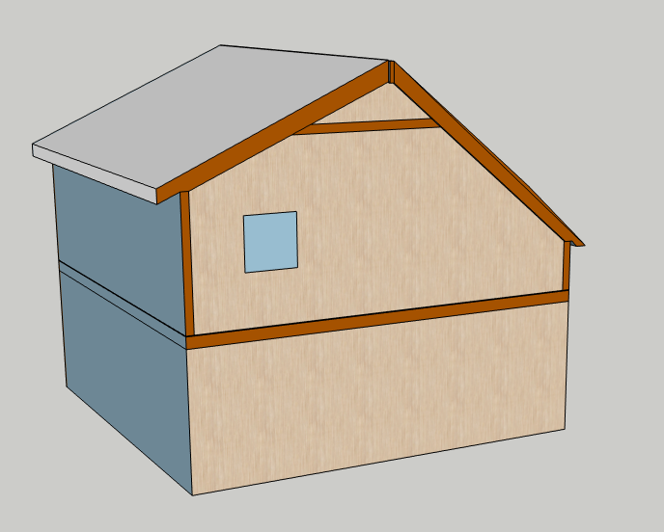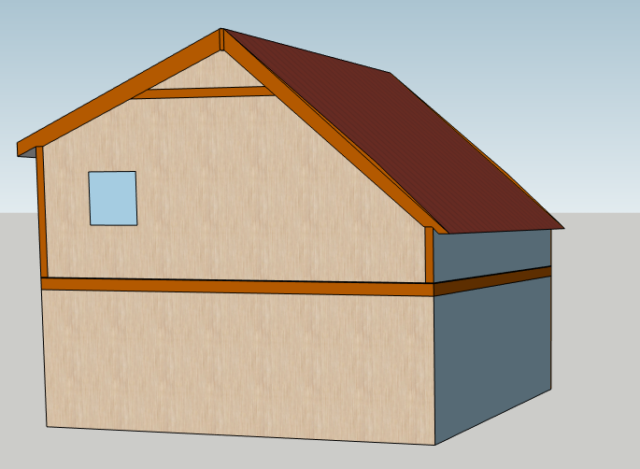**Amendment and Pitch Change**

5.5/12 Pitch

10/12 Pitch

Rafter Ties

Top of Upstairs floor

10’

8’

3’

7’6”

8’

**Noticeable Change**

Rafters sit on walls at both ends but have rafter ties 10 foot up.

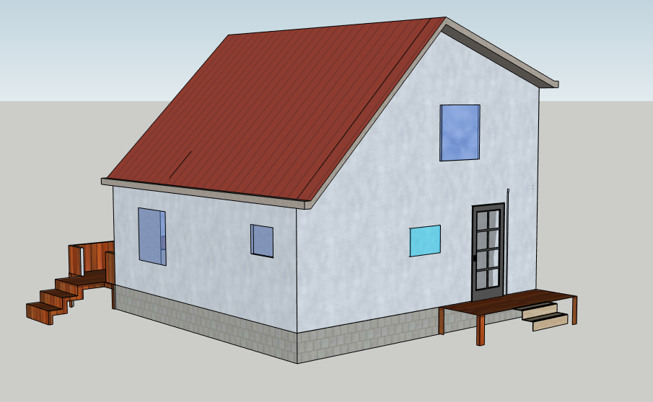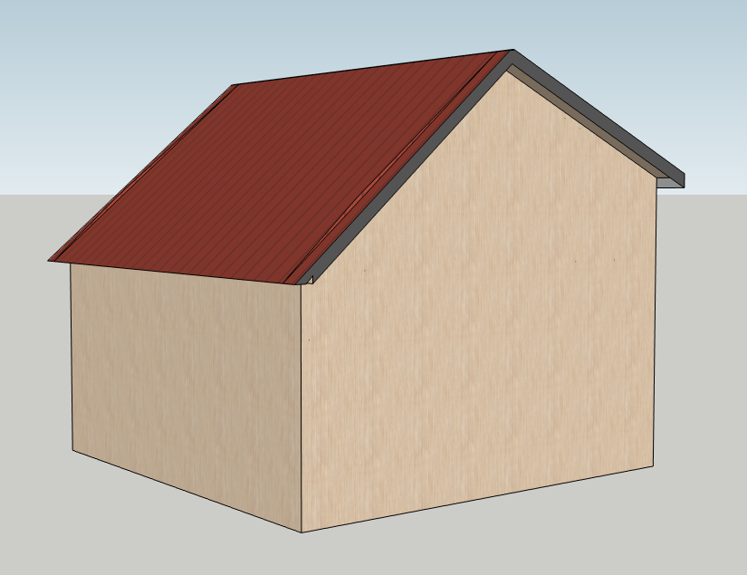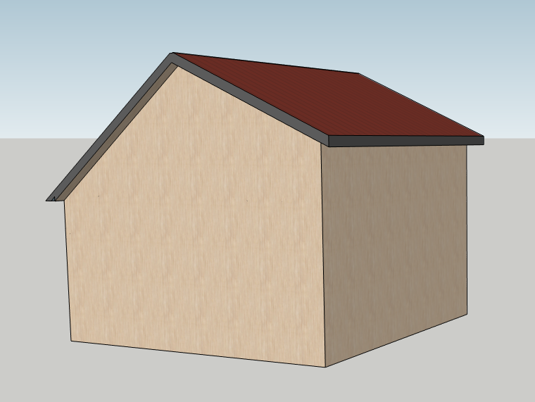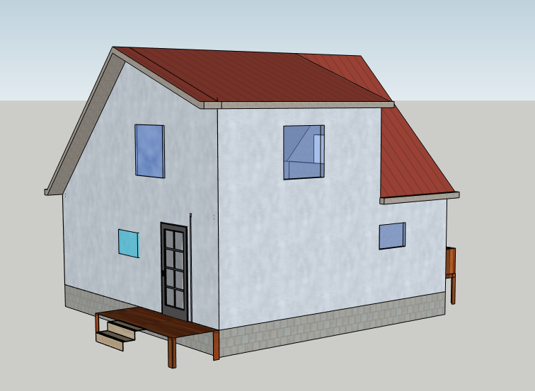

**Note**: New and Old design still contain upstairs loft

Dormer pushed all the way

16’2”

16’8”

11’

8’

**New Design**

Changed Specs

* No Dormer, pitch continues to end of house
* Lower slope side is a 5.5/12 pitch (steeper)
* 10/12 pitch on opposite side of house
* 10/12 side rafter sits on a 3’ wall (above upstairs floor)
* 5.5/12 side rafter sits on 7’6” wall (above upstairs floor).

**Old Design**

Old Specs

* Dormer
* 4/12 dormer pitch
* 12/12 pitch after dormer ends on same side of house
* 12/12 opposite side pitch
* Rafter sits on floor on 12/12 pitch side and 8’ wall on dormer side